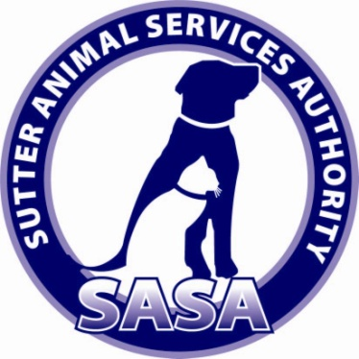
Friends
Of the
Sutter Animal Services Authority

VOLUNTEER APPLICATION
Friends of SASA, 501c3 Non-Profit
Organization

Dear Volunteer,
Thank you for your interest in volunteering with the Friends of SASA. You must be 18 years of age to volunteer with our organization.

We are very involved with fundraising and are always seeking volunteers to assist with our events. We need friendly, professional, and responsible volunteers that are committed and who truly want to make a difference in the lives of homeless animals.

I hope you will consider joining and helping us to make an impact. The first step in the process is to complete a short application as a way of introduction.

On behalf of the entire Board of Directors we look forward to hearing from you.

Regards,
Helen Asher
President, Friends of SASA

_____________________________________________________________ Friends of SASA –Volunteer Page 1

Date:_____________

First Name____________________________Last Name_______________________________

Address________________________________________________________________________

City______________________________County_______________State______Zip__________

Home Phone_________________________Cell Phone__________________________________

Email Address___________________________________________________________________

Employer_______________________________________________________________________

Position Held______________________________Work Phone___________________________

Employer Address________________________________________________________________

Describe any present or previous volunteer work you have done:

Any special talents or skills that would benefit our organization:

Interest
⁪ Committee
⁪ Events
⁪ Fundraising

______________________________________________________________________________________
Friends of SASA-Volunteer Page 2

Availability
⁪Monday ⁪Tuesday ⁪Wednesday ⁪Thursday ⁪Friday ⁪Saturday ⁪Sunday

Times Available:____________________________________________________________________

Any physical limitations
⁪ Yes ⁭ No

In case of emergency contact: Name_____________________________Phone_________________

Please return completed application to:
Friends of SASA
200 Garden Highway
Yuba City, CA 95991
Or
Email to:
Friendsofsasa@gmail.com

⁭Agree *As a volunteer for our organization, I agree to abide by the policies and procedures. I understand that I will be volunteering at my risk and that the organization, its employees, and affiliates, cannot assume any responsibility for any liability for any accident, injury or health problem which may arise from any volunteer work I perform for the organization. I agree that all the work I do is on a volunteer basis and I am not eligible to receive any monetary payment or reward.

____________________________________________________________________________________________________________
Friends of SASA – Volunteer Page 3

